Jala Home Solution
Mini Sofa Catalog

Mini Sofa Combed Collection
Mini Sofa Combed Collection is upholstered in a combed chenille-boucle fabric for a soft, textured touch and durable everyday seating. Each piece has a clover-shaped silhouette — a curved wraparound backrest, a round bolster cushion, and a plush round ottoman-style seat — offering a cozy, compact accent piece for small living spaces, corners, or reading nooks.

Combed Mini Sofa
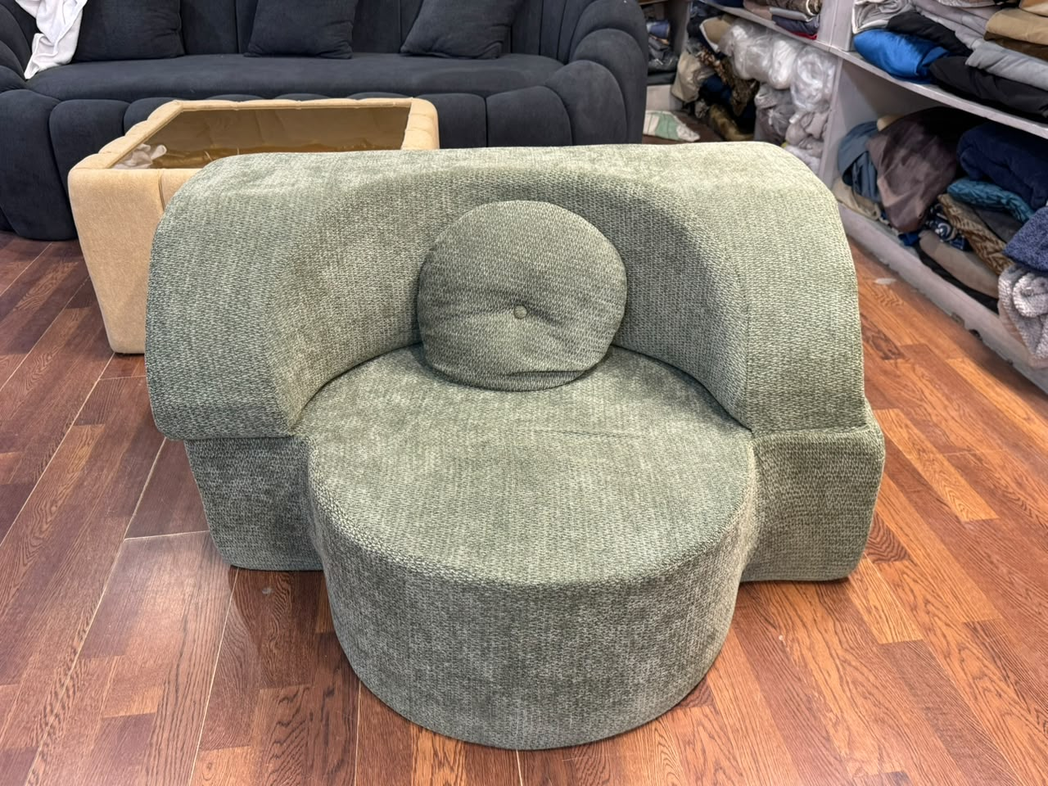 | 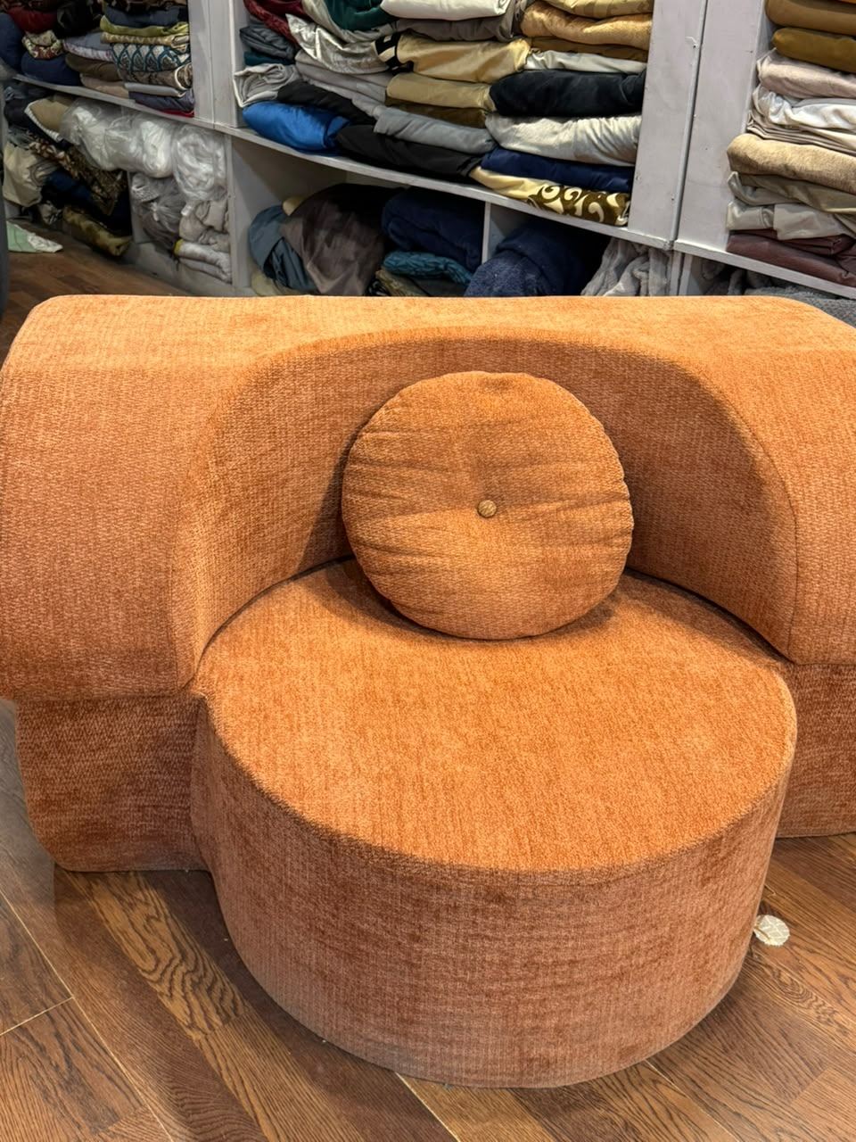

Rs. 26000 Rs. 20000 Save 23%
Combed chenille-boucle upholstery with a curved wraparound backrest and round bolster for a soft, sculptural look — shown here in Sage Green and Rust Terracotta.
Item Name: Combed Mini Sofa
Type: Mini Sofa
Design: Clover-Shaped Wraparound Backrest, Round Bolster Cushion, Round Ottoman Seat
Colors Available: Sage Green, Rust Terracotta
Quality: Combed Chenille-Boucle Fabric
Stock: Available on request

